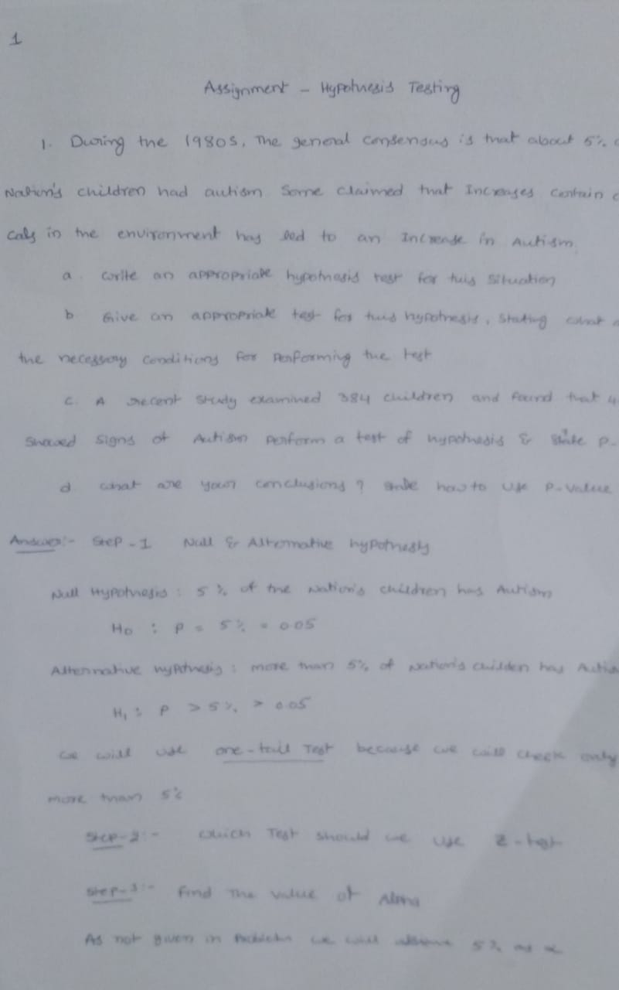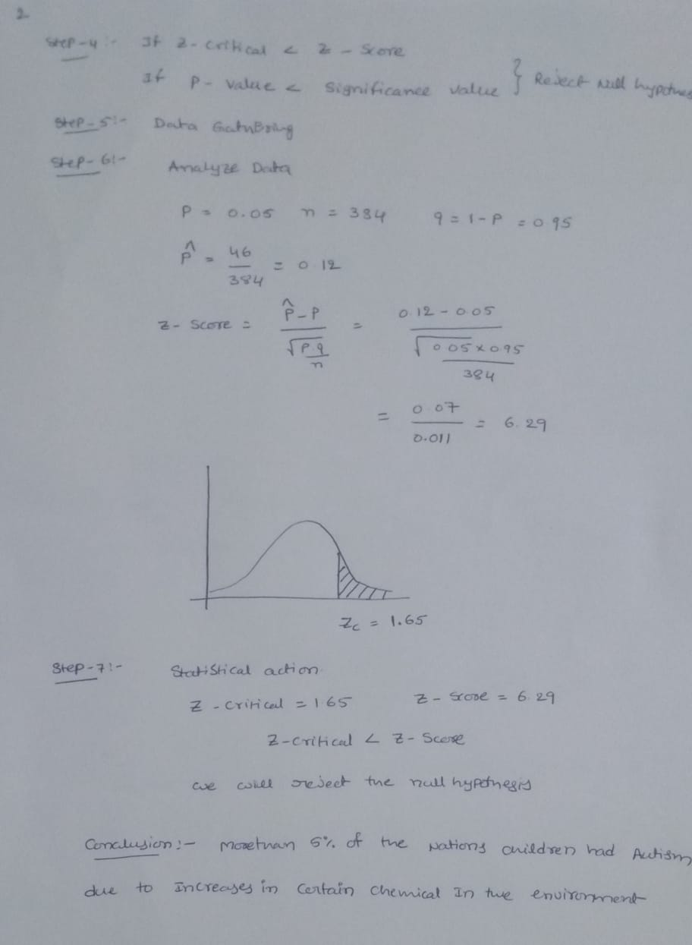

2. A company with a fleet of 150 cars found that the emission system of 7 our of the 22 cars tested failed to meet pollution guidelines. (a) Write a hypothesis to test if more than 20% of the entire fleet might be out of compliance. (b) Test the hypothesis based on the binomial distribution and report a p-value. (c) Is the test significant at the 10%, 5%, 1% level

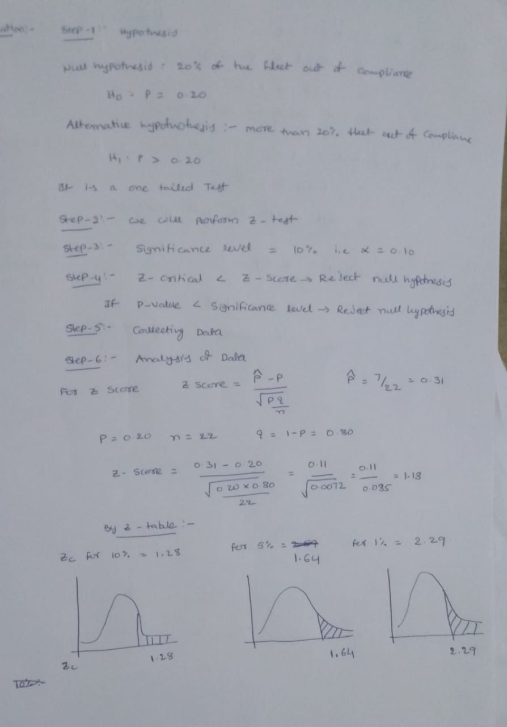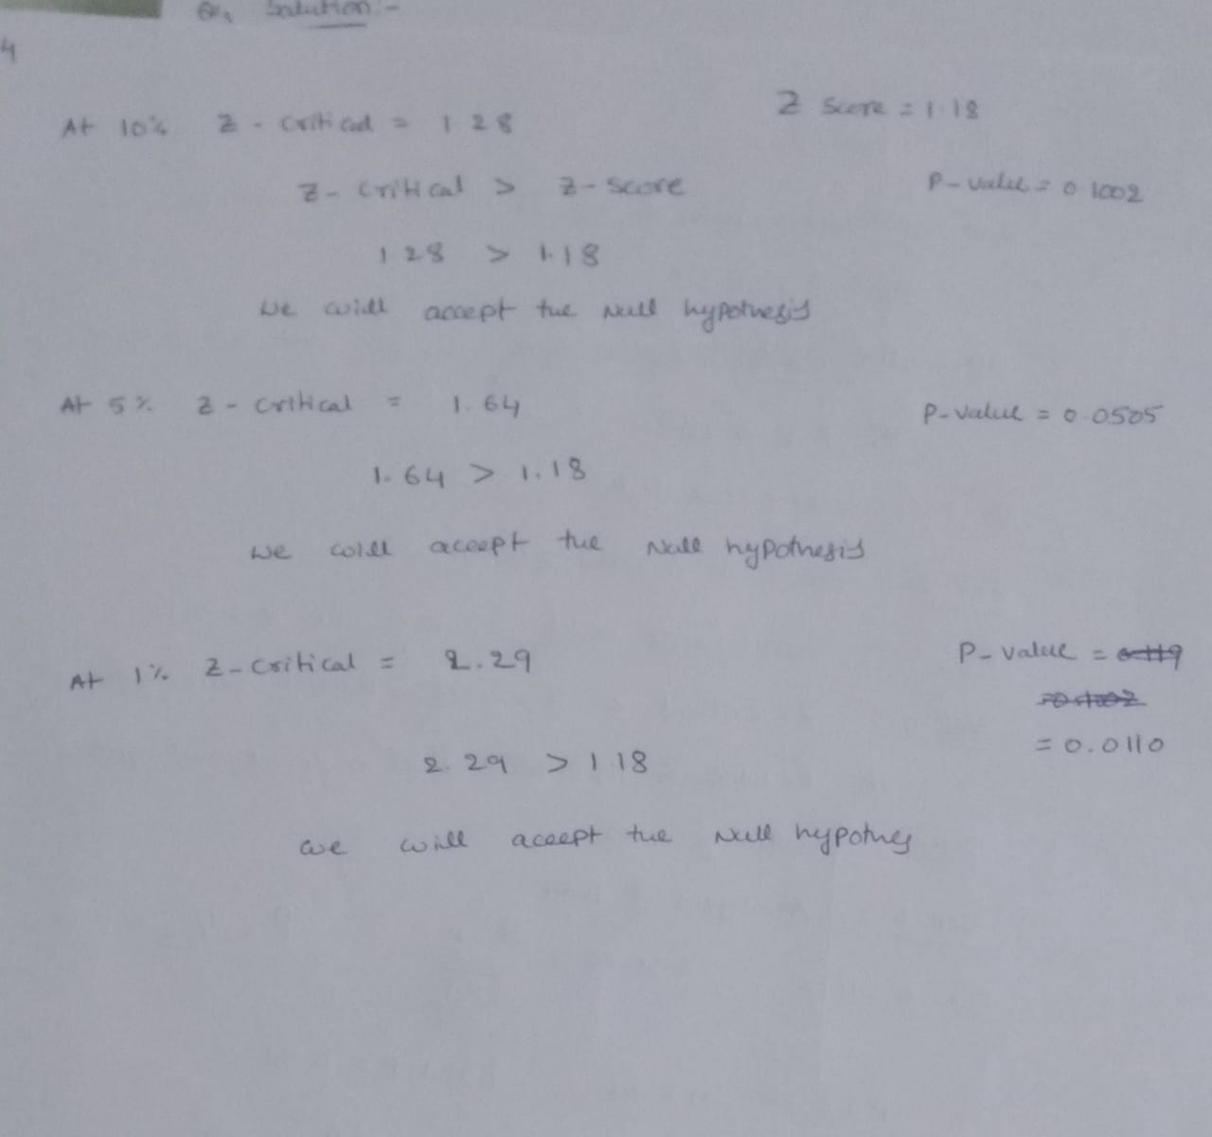

3. National data in the 1960s showed that about 44% of the adult population had never smoked. (a) State a null and alternative hypothesis to test that the fraction of the 1995 population of adults that had never smoked had increased. (b) A national random sample of 891 adults were interviewed and 463 stated that they had never smoked. Perform a z-test of the hypothesis and give an approriate p-value. (c) Create a 98% confidence interval for the proportion of adults who had never been smokers. (d) Give the value of the power function π(p) for p = 0.46, 0.48, 0.50, 0.52 with the choice of α = 0.02 and a “greater than” alternative hypothesis. (e) Compute the power function for these values if we increase the sample to 1600. Explain why these values increased.

